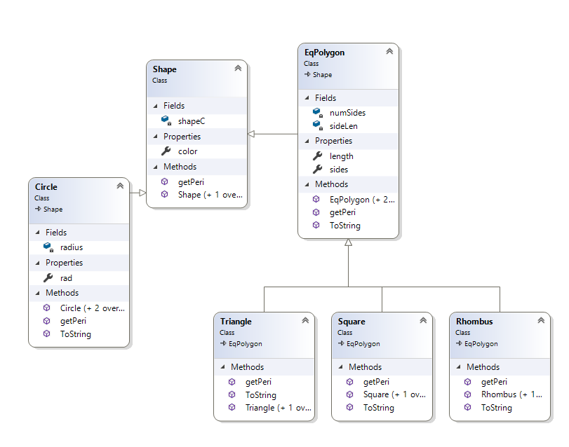

This is my class hierarchy for EX01 of homework 2. In this, it can be seen that inheritance is used in multiple places. First, it is used in EqPolygon and Circle to inherit the member color from shape. The method getPeri() is declared initially in Shape, however it cannot be implemented in Shape as it is a virtual function. Shape is a generic shape class and does not have member variables for side length or radius, so getPeri() would be pointless to implement inside of the Shape class.

There is more inheritance shown in the classes Triangle, Square, and Rhombus. All of these inherit from EqPolygon, which means that all of these new classes are equilateral polygons. Every side is the same length. Along with that, all of these classes inherit the sideLen and length member variables, which is why there are no length variables declared in the children classes. However, each of the children classes has a different version of getPeri that is specific to that child class. For example, triangle’s getPeri multiplies the sideLen by three, while the getPeri for square multiplies the sideLen by 4. Along with that, the ToString method prints information about the shape, saying the shape, its color, and its sideLen.